;Program to add two hexadecimal numbers

mov a,#21H ;1st hexadecimal number

mov b,#42H ;2nd hexadecimal number

add a,b

mov 10h, a ;store SUM in memory location 40H

end

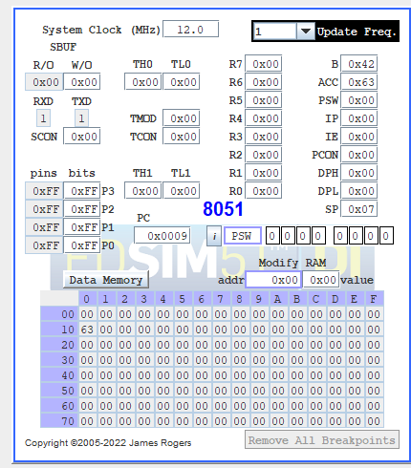

;Program to multiply two decimal numbers

mov a,#02

mov b,#05

mul ab ;multiplication

mov 43h, a

mov 42h, b

END

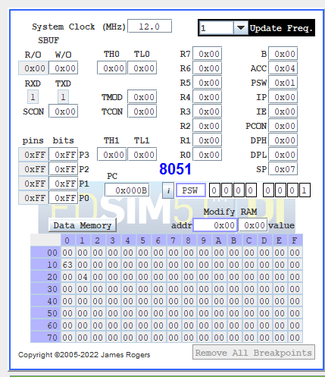

;Program to divide two decimal numbers

mov a,#05 ;1st decimal number

mov b,#02 ;2nd decimal number

div ab

mov 44h, a ;Quotient

mov 45h, b ;Remainder

end

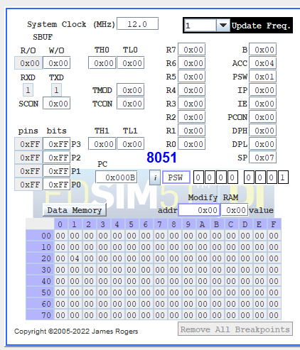

;Increment and decrement the content of accumulator

mov a,#25h

inc a

mov 46h, a

dec a

dec a

mov 47h, a

end

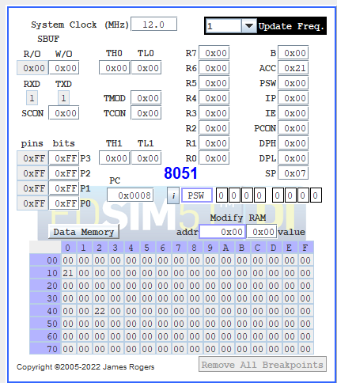

;Another program

ORG 0000

mov R0, #56H

mov R1, #25H

mov A, #48H

ADD A, R0

mov @R1, A

inc R1

add A,@R0

mov @R1, A

inc R1

add A, 40H

mov @R1, A

clr A

add A,#39H

inc R1

mov @R1,A

end

